Low-Level Design (LLD) — Complaint Category Module
Attribute | Value
Module | Complaint Category (Complaint Categories Master)
Menu path | SYSTEM CONFIGURATION → Complaint Categories
Landing page | complaint_categories.php
Application | Complaint / Dealer Portal
Stack (target) | Core PHP + MySQL (PDO)
Stack (current repo) | Core PHP + PostgreSQL via PDO
Document version | 1.0
Access | System Admin only (role id 6) — no RBAC module slug

â”€â”€â”€â”€â”€â”€â”€â”€â”€â”€â”€â”€â”€â”€â”€â”€â”€â”€â”€â”€â”€â”€â”€â”€â”€â”€â”€â”€â”€â”€â”€â”€

1. Module Overview

1.1 Purpose
System Administrators maintain the complaint category catalog in complaint_categories: create/edit categories (name + status), list/filter via DataTables, view details, and soft-delete. Complaint Entry consumes active, non-deleted options and stores both complaint_category_id and a denormalized complaint_category_name snapshot on complaints.

1.2 Scope
In scope | Out of scope
List / Add / Edit / Details / Soft-delete | Complaint Entry form UX (consumer only)
Active / Inactive status | Hard delete
Case-insensitive name uniqueness | Select2 on admin form (native select)
Create abuse / rate-limit guard | Cascading updates to existing complaints
Status list filter | Per-role RBAC module slug

1.3 High-level architecture
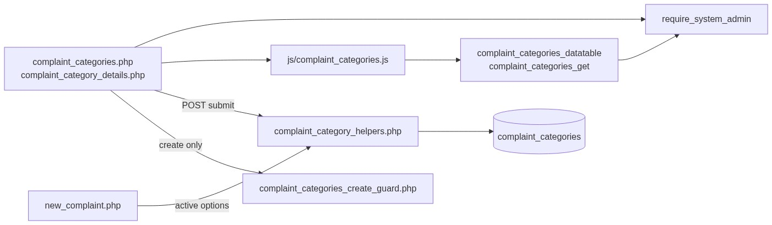
Figure 1 — High-level architecture
â”€â”€â”€â”€â”€â”€â”€â”€â”€â”€â”€â”€â”€â”€â”€â”€â”€â”€â”€â”€â”€â”€â”€â”€â”€â”€â”€â”€â”€â”€â”€â”€

2. Functional Requirements
ID | Requirement | Priority
FR-01 | System Admin can open Complaint Categories list (DataTables) | Must
FR-02 | Create category with name and status | Must
FR-03 | Edit category via inline slide-down form | Must
FR-04 | Soft-delete category; hide from list | Must
FR-05 | Unique category name among non-deleted (case/trim-insensitive) | Must
FR-06 | Filter list by status (active / inactive) | Should
FR-07 | View read-only details | Should
FR-08 | Throttle / rate-limit create requests | Should
FR-09 | Client validate.js for name + status | Should
FR-10 | Expose active options to Complaint Entry | Must

â”€â”€â”€â”€â”€â”€â”€â”€â”€â”€â”€â”€â”€â”€â”€â”€â”€â”€â”€â”€â”€â”€â”€â”€â”€â”€â”€â”€â”€â”€â”€â”€

3. User Roles & Permissions

3.1 RBAC module slug
None. Complaint Categories administration is gated by System Admin (SYSTEM_ADMIN_ROLE = 6), not a permission slug.

3.2 Permission matrix
Capability | Gate
All category admin pages | require_system_admin($obconn)
Category APIs | admin_api_require_system_admin
Denied | Access denied. System Admin privileges required.

Pages (complaint_categories.php, complaint_category_details.php, delete_complaint_category.php) are in rbac_admin_pages() and skip module RBAC; System Admin check is authoritative.

3.3 Page / API mapping
Resource | Gate
complaint_categories.php | System Admin
complaint_category_details.php | System Admin
delete_complaint_category.php | System Admin
api/complaint_categories_datatable.php | System Admin API
api/complaint_categories_get.php | System Admin API

3.4 Consumer access
Complaint Entry users need complaint-entry permissions (separate module). They only see active categories via complaint_category_get_active_options().
â”€â”€â”€â”€â”€â”€â”€â”€â”€â”€â”€â”€â”€â”€â”€â”€â”€â”€â”€â”€â”€â”€â”€â”€â”€â”€â”€â”€â”€â”€â”€â”€

4. Business Rules
ID | Rule
BR-01 | Soft-deleted rows (deleted_at IS NOT NULL) excluded from list, get, uniqueness, and Entry options.
BR-02 | Name unique among non-deleted: LOWER(TRIM(name)); edit excludes self.
BR-03 | Soft-deleted names may be reused on create.
BR-04 | Status must be active or inactive (rbac_validate_status).
BR-05 | Inactive categories remain in admin list but are not offered in Complaint Entry.
BR-06 | Soft-delete does not update existing complaints rows (snapshot name retained).
BR-07 | No “in use” check before soft-delete.
BR-08 | Create-only abuse guard: max 1 record/request; min 3s interval; max 20 creates / 15 min.
BR-09 | Edit requires existing non-deleted row.
BR-10 | created_by = current user id on insert; created_at / updated_at timestamps.
BR-11 | Details/delete URL ids are base64_encode((string) id).
BR-12 | Create/update stay on page (no PRG). Delete redirects to list with session flash.
BR-13 | Complaint Entry resolves category via complaint_category_resolve_for_complaint (active + non-deleted).
BR-14 | Complaint stores complaint_category_id + denormalized complaint_category_name.

â”€â”€â”€â”€â”€â”€â”€â”€â”€â”€â”€â”€â”€â”€â”€â”€â”€â”€â”€â”€â”€â”€â”€â”€â”€â”€â”€â”€â”€â”€â”€â”€

5. Database Design

5.1 ER diagram
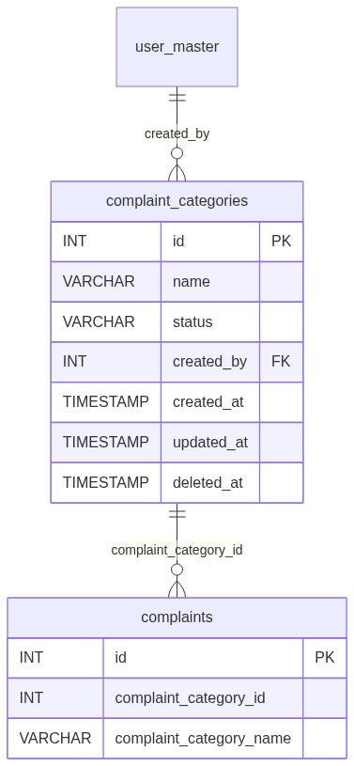
Figure 2 — Entity relationship diagram

5.2 Table: complaint_categories
Column | MySQL type | Notes
id | INT UNSIGNED AUTO_INCREMENT | PK
name | VARCHAR(100) | Required; unique among active
status | VARCHAR(20) | active / inactive
created_by | INT NULL | → user_master.id
created_at | TIMESTAMP | Insert
updated_at | TIMESTAMP NULL | Update / soft-delete
deleted_at | TIMESTAMP NULL | Soft-delete

5.3 Related tables
Table | Role
user_master | Created-by join on details
complaints | Consumer; id + name snapshot

5.4 Reference / lookup sources
Source | Usage
rbac_status_options() | Status <select>
complaint_category_get_active_options() | Complaint Entry dropdown
Status filter | DataTable ajax reload

â”€â”€â”€â”€â”€â”€â”€â”€â”€â”€â”€â”€â”€â”€â”€â”€â”€â”€â”€â”€â”€â”€â”€â”€â”€â”€â”€â”€â”€â”€â”€â”€

6. API / Backend Design

6.1 Page endpoints
Endpoint | Method | Auth | Description
complaint_categories.php | GET | System Admin | List + Add/Edit panel
complaint_categories.php | POST submit_complaint_category | System Admin | Create or update
complaint_category_details.php?id= | GET | System Admin | Read-only details
delete_complaint_category.php?id= | GET | System Admin | Soft-delete

6.2 JSON APIs

POST api/complaint_categories_datatable.php
DataTables server-side. Optional status_filter. Search on name (+ status label via rbac_search_filter). Only deleted_at IS NULL.
{
"draw": 1,
"recordsTotal": 10,
"recordsFiltered": 2,
"data": [{ "id": "#1", "name": "...", "status": "...", "actions": "<html>" }]
}

GET api/complaint_categories_get.php?id=
Returns category fields for edit form. System Admin API gated.

6.3 Supporting lookup APIs
N/A for admin UI (status options server-rendered). Entry uses helper options, not this admin API.

6.4 Core PHP responsibilities
File | Role
includes/complaint_category_helpers.php | from_post, validate, CRUD, options, display
includes/module_create_guards/complaint_categories_create_guard.php | Create throttle / rate limit
includes/admin_access_helpers.php | System Admin gate
includes/admin_api_guard.php | System Admin API gate
includes/rbac_helpers.php | Status options / validation / badges

â”€â”€â”€â”€â”€â”€â”€â”€â”€â”€â”€â”€â”€â”€â”€â”€â”€â”€â”€â”€â”€â”€â”€â”€â”€â”€â”€â”€â”€â”€â”€â”€

7. Validation Rules

7.1 Server-side
Field / rule | Message
Name empty | Category name is required.
Name > 100 | Category name cannot exceed 100 characters.
Status missing/invalid | Status is required.
Duplicate name | Category name already exists. Please choose a different name.
Missing edit target | Complaint category not found or already deleted.
Create throttle | Please wait a few seconds... / rate-limit messages

7.2 Client-side (js/complaint_categories.js)
â€¢ validate.js: name presence + max 100; status presence
â€¢ Submit blocked until valid; then native form.submit()
â€¢ Status filter reloads DataTable
â€¢ Success alert fades after 3s
â”€â”€â”€â”€â”€â”€â”€â”€â”€â”€â”€â”€â”€â”€â”€â”€â”€â”€â”€â”€â”€â”€â”€â”€â”€â”€â”€â”€â”€â”€â”€â”€

8. UI Screen Specifications

8.1 Listing — complaint_categories.php
Element | Spec
CTA | Add Complaint Category / Cancel
Filter | Status (All / Active / Inactive)
Grid | ID, Name, Status, Created At, Action
Actions | View / Edit / Delete (confirm)
Form card | #complaintCategoryFormCard slide-down

8.2 Form panel
Fields: Category Name*, Status* (active / inactive).
Hidden: record_id, submit_complaint_category.

8.3 Details — complaint_category_details.php
Read-only name, status badge, created by, timestamps.

8.4 Modals / Select2
â€¢ No CRUD modals; delete uses browser confirm(...).
â€¢ Admin form: native <select> for status — no Select2.
â€¢ Complaint Entry: Select2 on #complaintCategorySelect (consumer).
â”€â”€â”€â”€â”€â”€â”€â”€â”€â”€â”€â”€â”€â”€â”€â”€â”€â”€â”€â”€â”€â”€â”€â”€â”€â”€â”€â”€â”€â”€â”€â”€

9. Database Flow

9.1 Create
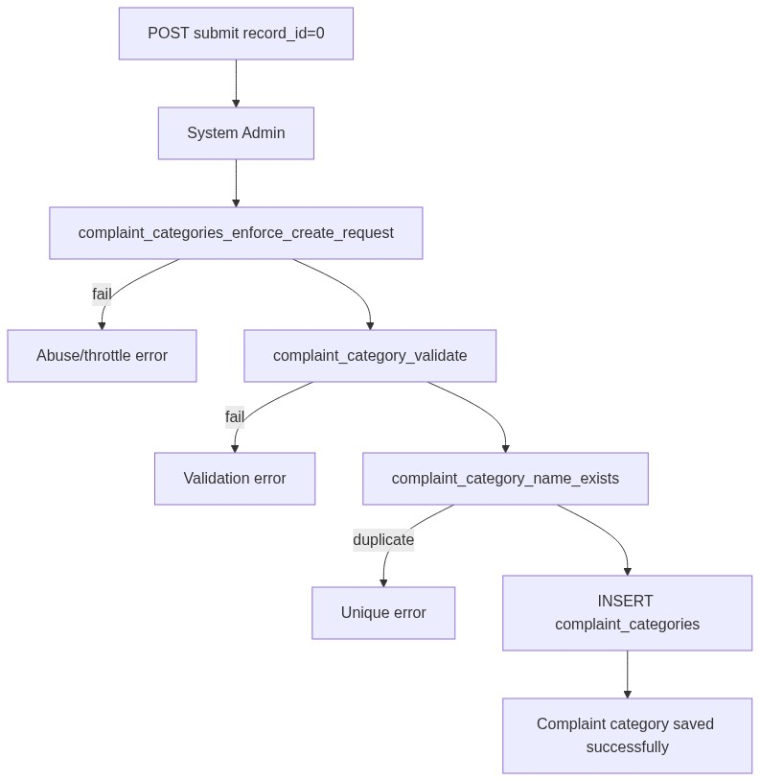
Figure 3 — Create database flow

9.2 Soft-delete
UPDATE complaint_categories
SET deleted_at = CURRENT_TIMESTAMP,
updated_at = CURRENT_TIMESTAMP
WHERE id = :id
AND deleted_at IS NULL;

9.3 List query pattern
SELECT *
FROM complaint_categories
WHERE deleted_at IS NULL
AND /* optional status = :status_filter */
AND /* optional name/status search */
ORDER BY id DESC
LIMIT :limit OFFSET :offset;
â”€â”€â”€â”€â”€â”€â”€â”€â”€â”€â”€â”€â”€â”€â”€â”€â”€â”€â”€â”€â”€â”€â”€â”€â”€â”€â”€â”€â”€â”€â”€â”€

10. Sequence Diagram

10.1 Create category
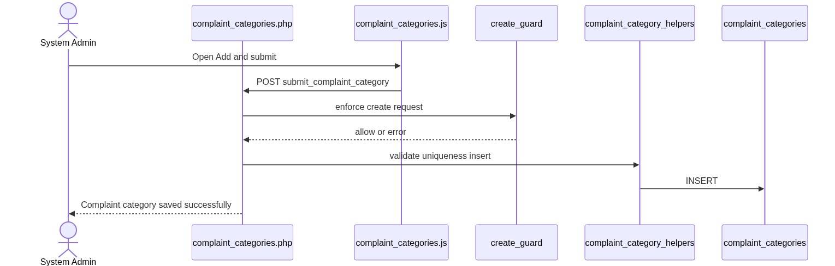
Figure 4 — Sequence: Create category

10.2 Soft-delete and Entry impact
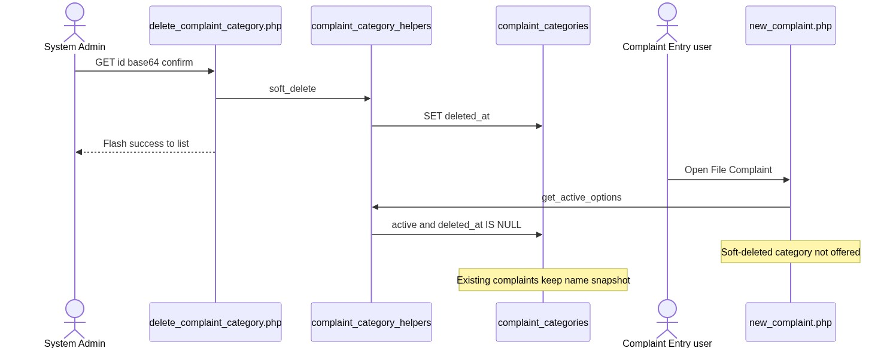
Figure 5 — Sequence: Soft-delete and Entry impact
â”€â”€â”€â”€â”€â”€â”€â”€â”€â”€â”€â”€â”€â”€â”€â”€â”€â”€â”€â”€â”€â”€â”€â”€â”€â”€â”€â”€â”€â”€â”€â”€

11. Activity Diagram
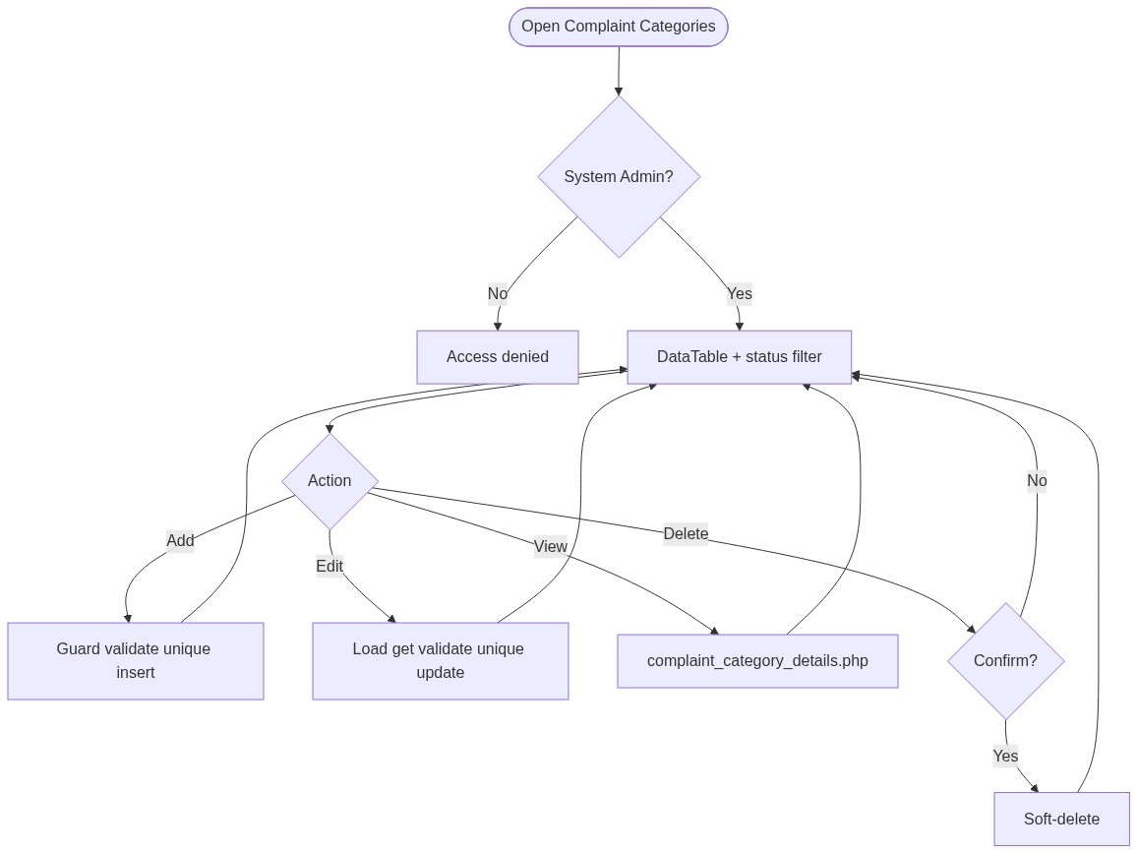
Figure 6 — Activity diagram
â”€â”€â”€â”€â”€â”€â”€â”€â”€â”€â”€â”€â”€â”€â”€â”€â”€â”€â”€â”€â”€â”€â”€â”€â”€â”€â”€â”€â”€â”€â”€â”€

12. Class / Module Diagram
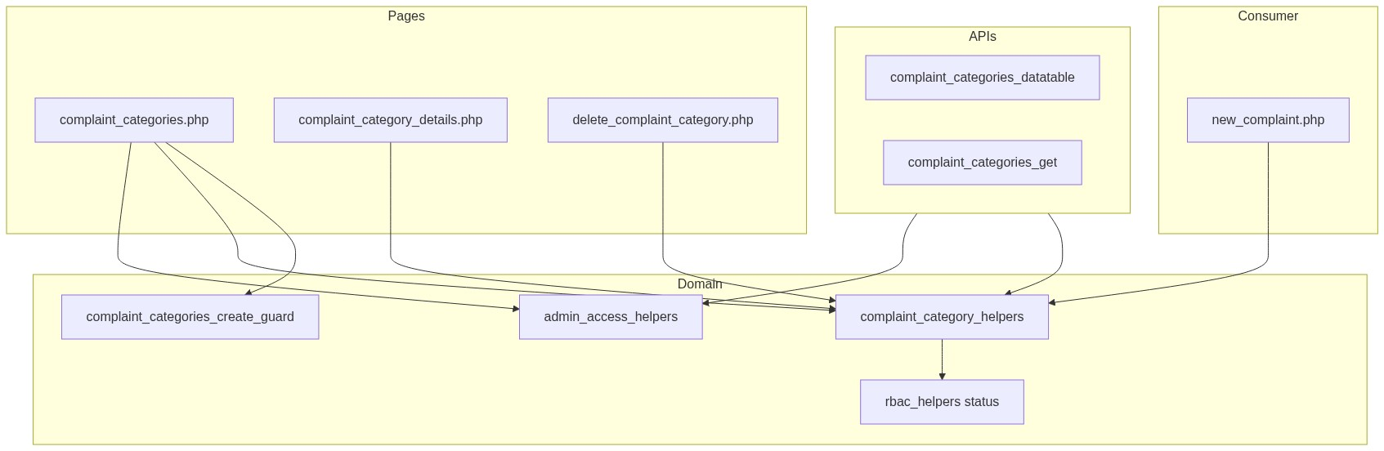
Figure 7 — Class / module diagram

12.1 Key functions
Function | Role
complaint_category_from_post / complaint_category_validate | Parse + validate
complaint_category_name_exists | Uniqueness
complaint_category_insert / _update / _soft_delete | Persist
complaint_category_get_by_id | Load non-deleted row
complaint_category_entry_actions | View / Edit / Delete HTML
complaint_category_get_active_options | Entry dropdown source
complaint_category_resolve_for_complaint | Validate id for Entry submit
complaint_category_render_options | <option> + data-name
complaint_category_display_name | Snapshot display on complaints
complaint_categories_enforce_create_request | Create abuse guard

â”€â”€â”€â”€â”€â”€â”€â”€â”€â”€â”€â”€â”€â”€â”€â”€â”€â”€â”€â”€â”€â”€â”€â”€â”€â”€â”€â”€â”€â”€â”€â”€

13. Folder Structure
ComplaintManagement/
├── complaint_categories.php
├── complaint_category_details.php
├── delete_complaint_category.php
├── api/
│ ├── complaint_categories_datatable.php
│ └── complaint_categories_get.php
├── includes/
│ ├── complaint_category_helpers.php
│ ├── admin_access_helpers.php
│ ├── admin_api_guard.php
│ ├── rbac_helpers.php
│ └── module_create_guards/
│ └── complaint_categories_create_guard.php
├── js/
│ └── complaint_categories.js
├── storage/
│ └── request_abuse/complaint_categories/
└── docs/
└── LLD_Complaint_Category_Module.md
â”€â”€â”€â”€â”€â”€â”€â”€â”€â”€â”€â”€â”€â”€â”€â”€â”€â”€â”€â”€â”€â”€â”€â”€â”€â”€â”€â”€â”€â”€â”€â”€

14. Error Handling
Layer | Pattern
Page POST | Local $error_message / $success_message
Delete | Session flash → complaint_categories.php
Details invalid | die('Invalid record.') / die('Complaint category not found.')
APIs | JSON + HTTP 403/404 as applicable
Create guard | Inline error + abuse log under storage

14.1 Common messages
Message | When
Complaint category saved successfully. | Create
Complaint category updated successfully. | Update
Complaint category deleted successfully. | Soft-delete (session flash)
Failed to save complaint category. / Failed to update... | Persist fail
Complaint category not found or already deleted. | Missing edit target
Category name already exists... | Unique violation
Please wait a few seconds before creating another record. | Min interval
Create rate limit exceeded... | 20 / 15 min
Access denied. System Admin privileges required. | Non-admin

â”€â”€â”€â”€â”€â”€â”€â”€â”€â”€â”€â”€â”€â”€â”€â”€â”€â”€â”€â”€â”€â”€â”€â”€â”€â”€â”€â”€â”€â”€â”€â”€

15. Security Considerations
Area | Control
Authorization | System Admin hard-gate on pages + APIs
Soft-delete | Excluded from active queries and Entry options
Create abuse | Throttle, rate limit, payload size, monitor log
XSS | Escaped alerts / table actions / details
CSRF | Not implemented on POST or GET delete
Delete method | GET soft-delete — CSRF-friendly; confirm only
PRG | Not used on create/update
Uniqueness | App-level only; race without DB UNIQUE
In-use check | None before soft-delete
Id encoding | Base64 obfuscation only; authz is admin gate
Snapshot integrity | Existing complaints keep name even if master changes/deletes

â”€â”€â”€â”€â”€â”€â”€â”€â”€â”€â”€â”€â”€â”€â”€â”€â”€â”€â”€â”€â”€â”€â”€â”€â”€â”€â”€â”€â”€â”€â”€â”€

16. Audit Logs

16.1 Built-in field-level audit
Field | Behavior
created_by / created_at | On create
updated_at | On update / soft-delete
deleted_at | Soft-delete
Dedicated audit table | Not implemented
Create abuse log | storage/request_abuse/complaint_categories/abuse_monitor.log

â”€â”€â”€â”€â”€â”€â”€â”€â”€â”€â”€â”€â”€â”€â”€â”€â”€â”€â”€â”€â”€â”€â”€â”€â”€â”€â”€â”€â”€â”€â”€â”€

17. Test Cases

17.1 Functional
ID | Scenario | Expected
TC-01 | Non-admin opens Complaint Categories | Denied
TC-02 | Create with empty name | Validation error
TC-03 | Create duplicate name (different case) | Rejected
TC-04 | Soft-delete then recreate same name | Allowed
TC-05 | Set status inactive | Still in admin list; not in Entry options
TC-06 | Soft-delete category used by complaints | Complaints keep snapshot name; Entry omits it
TC-07 | Status filter = inactive | Only inactive rows
TC-08 | Edit via pencil | Form filled from complaint_categories_get
TC-09 | Delete confirmed | Soft-deleted; flash success
TC-10 | Create twice within 3 seconds | Throttle error
TC-11 | Create >20 in 15 minutes | Rate-limit error
TC-12 | Entry submit with deleted category id | Rejected (Complaint Category is required. path)
TC-13 | Details with bad base64 id | Invalid record

â”€â”€â”€â”€â”€â”€â”€â”€â”€â”€â”€â”€â”€â”€â”€â”€â”€â”€â”€â”€â”€â”€â”€â”€â”€â”€â”€â”€â”€â”€â”€â”€

18. Assumptions & Dependencies

18.1 Assumptions
1. Role id 6 is System Admin.
2. Soft-delete is the only remove mechanism; hard deletes are not used.
3. Complaint lists/details/mail prefer denormalized complaint_category_name.
4. App-level uniqueness is sufficient unless a DB UNIQUE constraint is added later.
5. Document target stack Core PHP + MySQL; repo runs PostgreSQL.
6. Create guard storage directory is writable under storage/request_abuse/complaint_categories/.

18.2 Dependencies
Dependency | Purpose
admin_access_helpers / admin_api_guard | System Admin gate
rbac_helpers | Status options / validation / badges
Create-guard storage | Throttle state + abuse log
jQuery + DataTables + validate.js | List / form UX
Complaint Entry module | Consumer of active options

â”€â”€â”€â”€â”€â”€â”€â”€â”€â”€â”€â”€â”€â”€â”€â”€â”€â”€â”€â”€â”€â”€â”€â”€â”€â”€â”€â”€â”€â”€â”€â”€

Appendix A — Success flashes
Event | Message
Create | Complaint category saved successfully.
Update | Complaint category updated successfully.
Delete | Complaint category deleted successfully.

â”€â”€â”€â”€â”€â”€â”€â”€â”€â”€â”€â”€â”€â”€â”€â”€â”€â”€â”€â”€â”€â”€â”€â”€â”€â”€â”€â”€â”€â”€â”€â”€

Appendix B — Select2 control map
Screen | Control | Select2?
Admin form #complaintCategoryStatus | Native <select> | No
Entry #complaintCategorySelect | Static Select2 | Yes (consumer)

â”€â”€â”€â”€â”€â”€â”€â”€â”€â”€â”€â”€â”€â”€â”€â”€â”€â”€â”€â”€â”€â”€â”€â”€â”€â”€â”€â”€â”€â”€â”€â”€

Appendix C — Status values
Value | Admin list | Complaint Entry options
active | Yes | Yes
inactive | Yes | No
Soft-deleted | No | No

â”€â”€â”€â”€â”€â”€â”€â”€â”€â”€â”€â”€â”€â”€â”€â”€â”€â”€â”€â”€â”€â”€â”€â”€â”€â”€â”€â”€â”€â”€â”€â”€

Appendix D — Create guard limits
Limit | Value
Max records per request | 1
Min interval between creates | 3 seconds
Max creates per window | 20
Window | 15 minutes

â”€â”€â”€â”€â”€â”€â”€â”€â”€â”€â”€â”€â”€â”€â”€â”€â”€â”€â”€â”€â”€â”€â”€â”€â”€â”€â”€â”€â”€â”€â”€â”€

Appendix E — Complaint snapshot fields
Column | Source
complaints.complaint_category_id | Selected category id
complaints.complaint_category_name | Name snapshot from option data-name / resolve helper

â”€â”€â”€â”€â”€â”€â”€â”€â”€â”€â”€â”€â”€â”€â”€â”€â”€â”€â”€â”€â”€â”€â”€â”€â”€â”€â”€â”€â”€â”€â”€â”€
End of LLD — Complaint Category Module

